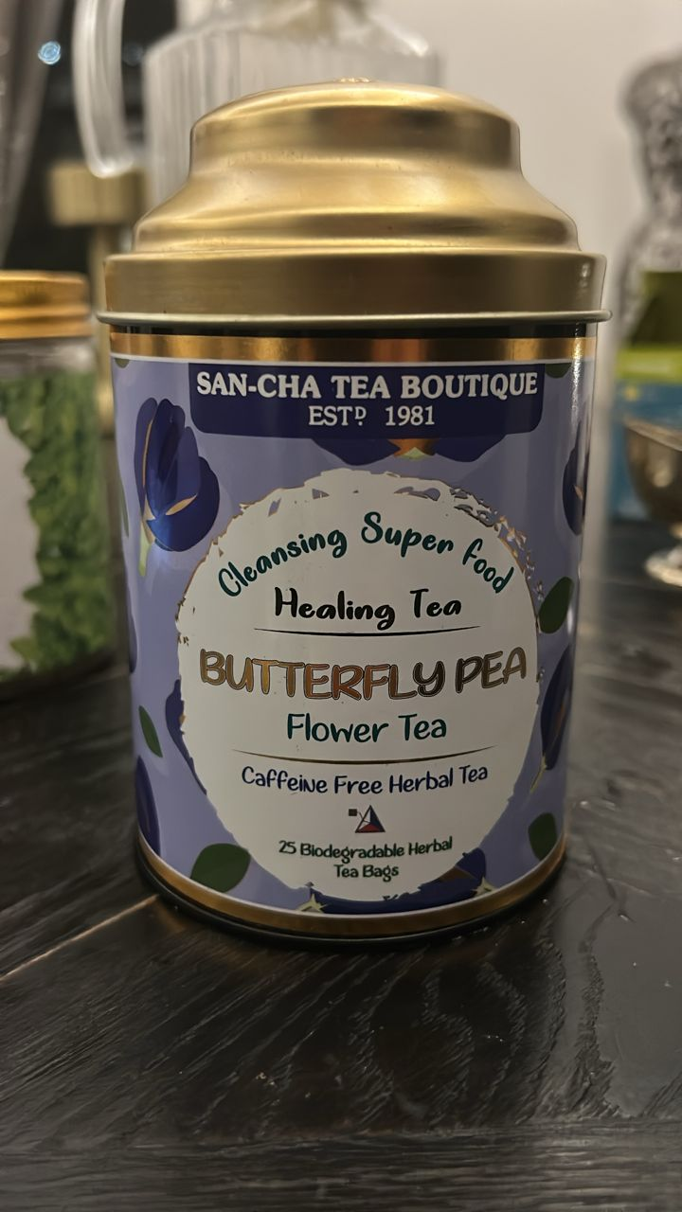
Butterfly Pea Flower Tea
WHAT IT IS
• Butterfly pea flower herbal tea, caffeine-free.
BENEFITS
• Rich in antioxidants.
• Supports hydration and relaxation.
HOW TO TAKE IT
• Steep 1 tea bag in hot water for 5–10 minutes.

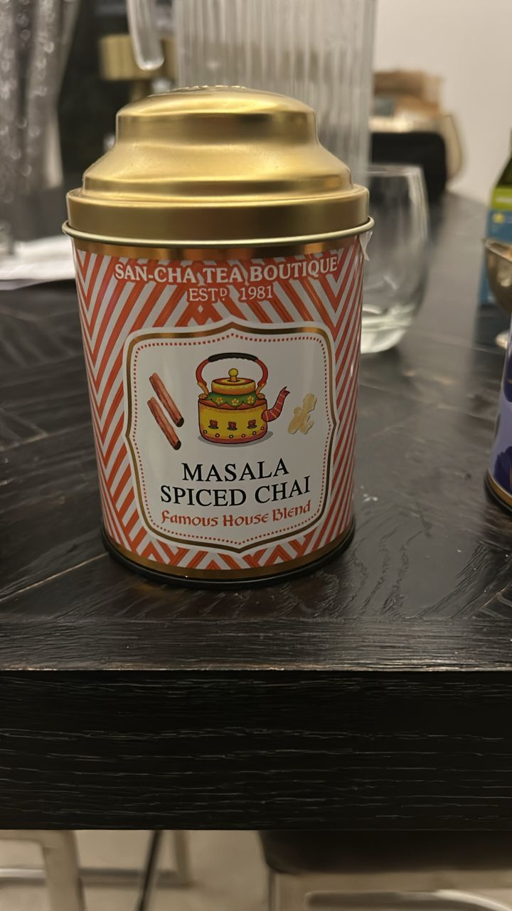
Masala Spiced Chai
WHAT IT IS
• Black tea blended with warming spices.
BENEFITS
• Boosts energy and digestion.
HOW TO TAKE IT
• Brew strong, add milk and sweetener.

Hawthorn Tea
WHAT IT IS  • Hawthorn berry/leaf herbal tea.  BENEFITS  • Supports heart and circulation.  HOW TO TAKE IT  • Steep 10–15 minutes, 1 cup daily. | 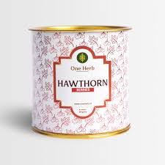

Lemon Balm Tea
WHAT IT IS  • Lemon balm herbal tea, caffeine-free.  BENEFITS  • Calms stress and supports sleep.  HOW TO TAKE IT  • Steep 1–2 tsp in hot water for 5–10 minutes. | 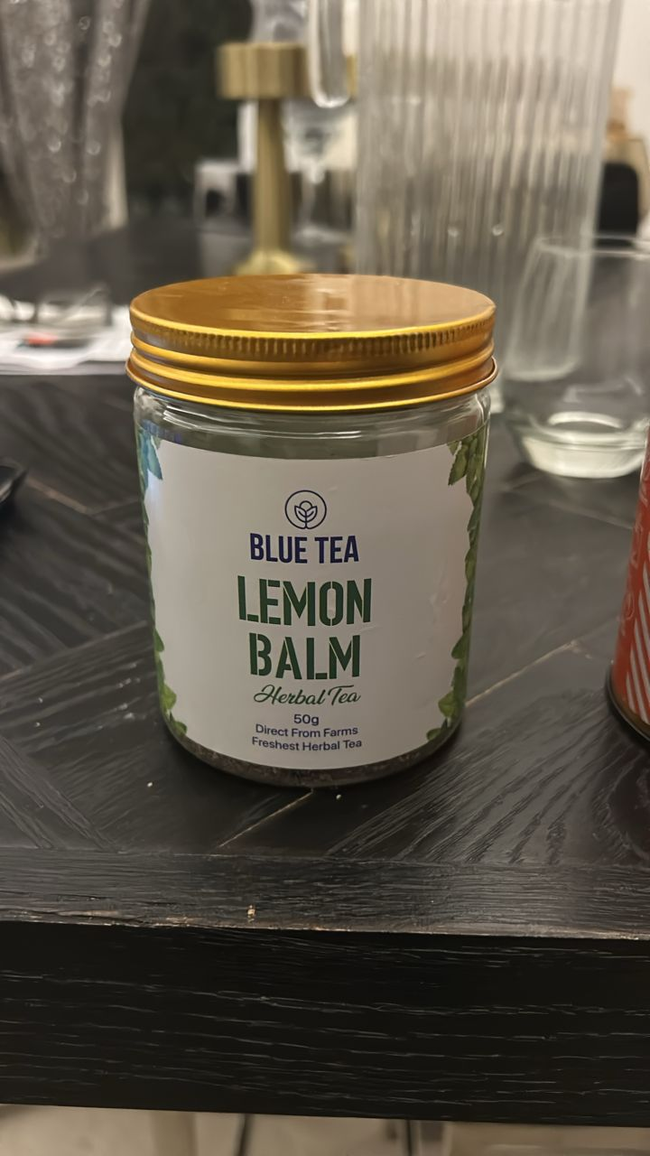

Mullein Leaves Tea
WHAT IT IS  • Mullein leaves herbal tea.  BENEFITS  • Soothes cough and respiratory irritation.  HOW TO TAKE IT  • Steep 10–15 minutes and strain well. | 